**CODE FOR THE AVERAGE CALCULATOR:**

#include <iostream>

using namespace std;

// Function to calculate the average

double calculateAverage(double* inputs, int size) {

double sum = 0.0;

for (int i = 0; i <size ; ++i) {

sum += inputs[i];

}

return sum / size;

}

int main() {

int Inputs;

cout << "How many inputs do you have? " << endl;

cin >> Inputs;

// Dynamically allocate memory for the inputs

double* inputs = new double[Inputs];

// ask the user to enter the inputs for the average

for (int i = 0; i < Inputs; ++i) {

cout << "Enter input " << i + 1 << ": ";

cin >> inputs[i];

}

// Calculate the average for the number given by user

double average = calculateAverage(inputs, Inputs);

// Output the result

cout << "The average of the inputs is: " << average << endl;

delete[] inputs;

return 0;

}

**OUTPUTS GAINED FOR THIS CODE:**

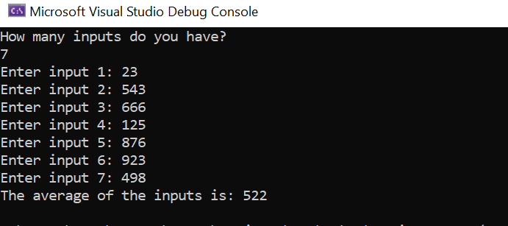**THERE ARE FEW SAMPLES:**



